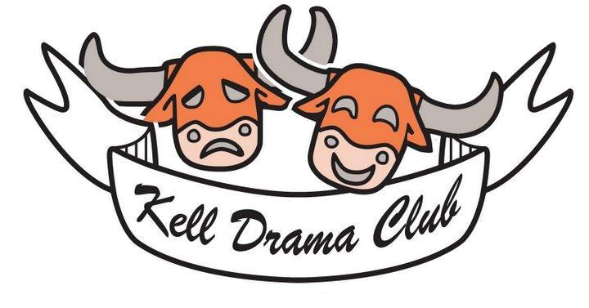

Hello, Kell Drama Families,
I am so pleased that your student is interested in participating in Kell High School’s next production. Attached you will find the Kell Drama Handbook and Calendar which we ask all students and families to sign prior to casting and crew assignments. This year’s Drama Club productions will be Clue (October 22, 23, 25) and Tuck Everlasting (March 26-28). Parent Meeting will be Tuesday, September 2 at 6:00 (Fall) and Tuesday, January 6 at 6:00 (Spring).

What does it take to produce a play?
Kell High School does not directly fund our productions. All costs must be covered by dues, fundraising, and ticket sales. In addition, many hours are needed for production, chaperoning, box office and other activities. We also provide meals for students on long rehearsal days and performance nights. Families also donate all snacks and water for our daily snacks as well as items to be sold at concessions as a fundraiser.

The cost of each production varies but is typically $5,000 for a play and $7500 for a musical. Meals are an additional expense. Each meal costs approximately $250. In addition, we have several weekend production shifts and requiring volunteers.

How can you help?
Volunteers are also needed to help with Set Construction and Painting, Costuming/Laundry, Chaperoning, Box Office, Concessions, Photography, and Meals. Sign-Up Genius will be used to request volunteers for each show. To cover these costs and needs, parents are asked to contribute in one of the following ways:
- 0 Dues + 4 Volunteer Shifts or 2 Meals
- $50.00 Dues + 2 Volunteer Shifts
- $50.00 Dues + 1 Meal Shift
- $100.00 – No Volunteer Shifts
I appreciate your time in reading through this explanation of our needs, and I look forward to working with you this year. Please do not hesitate to reach out to me with questions, concerns, or ideas. I can best be reached at gary.hicks@cobbk12.org, or you may leave a voicemail at (678) 494-7844, x050, and I will return your call.

Kell Drama Handbook
2025-2026
Students who wish to participate in Drama Club, audition for productions or be considered for crew positions and spotlights must turn in the following agreement signed by at least one parent or guardian and the student. If cast or selected for crew, students and parents agree to abide by these rules. Students must turn in a new contract for each production.
Auditions / Cast, Crew, and Spotlights
Submission of a signed contract is for permission to audition or interview only and does not guarantee or imply a role or specific crew assignment. Auditions and Crew Assignments are competitive. Those who perform best at auditions and who are right for the roles and jobs available will be selected. Following auditions and interviews, I will meet with individual students who would like feedback. I do not discuss casting or crew placement with parents.

Attendance, Conduct and Academic Standing
Students are expected to maintain excellent attendance, conduct, and academic standing. Students who have attendance, conduct, or academic issues may be dismissed. Students who quit a production rather than accept an assigned penalty will no longer be eligible to participate in the Kell Drama Program for the remainder of the year.
Attendance at School
Students who are absent from school may not attend rehearsal; per Cobb County School District (CCSD) policy, a student must be present at school for at least one half of the day to participate in extracurricular activities. Per CCSD policy, students who serve ISS may not participate in rehearsal on those days.
Conduct
The most important expectation of Kell Theatre students is that they treat one another, the school, and the community with respect and kindness both in person and online. Students who violate this expectation will be dismissed from the production and may be ineligible to participate in the program for the remainder of the semester or year. All Cobb County and Kell High School Policies regarding Extracurricular Activities are also in effect.

Dismissal Due to Conduct
- Students who accumulate three days ISS or any OSS will be dismissed.
- In exceptional situations such as fighting, substance abuse, disrespect, or offensive language, students may be dismissed from a production without prior warning.
Academic Standing
Students must maintain academic eligibility in accordance with school policy. Students must earn 3 credits in the fall to be eligible for spring productions. Georgia High School Association (GHSA) policy, students must be in good academic standing to perform at One Act Play (Fall).
Rehearsal Commitment
Students are expected to attend all rehearsals unless specifically excused. Students must notify Mr. Hicks at auditions of any conflicts with the rehearsal calendar. Parents please note: No non-emergency absences are allowed during the final three weeks of rehearsal and production.
Calendar - The rehearsal calendar is prepared carefully to accommodate school events, facility needs, and adequate rehearsal time. The calendar is accessible via the Kell Drama Club website located at https://garyhicks.wixsite.com/kell-drama-club.
Transportation - Parents must arrange for timely transportation from rehearsals and performances. Please prearrange pick-up from all rehearsals and events. We also ask that you provide an emergency contact who is authorized to pick up your student.
Parents / Volunteers – Parent volunteers are essential to the success of every production. There will be one required meeting for each production. Each student participating is asked to send an adult family member. Parents may volunteer to assist with chaperoning, box office, concessions, costumes/laundry; construction/painting, donations for snacks and other needs. Each family is asked to contribute in the way that suits them best. Volunteers will be organized through Sign-Up Genius and Remind.

Dues – Dues are requested but not required for each Drama Club production. There are a variety of options for paying Dues through financial or volunteer support.

Contribution Options
- 0 Dues + 4 Volunteer Shifts or 2 Meals
- $50.00 Dues + 2 Volunteer Shifts
- $50.00 Dues + 1 Meal Shift
- $100.00 – No Volunteer Shifts
Kell Drama Production
SIGNATURE PAGE
Dear Families,
I am so glad that your student is interested in participating in our current production. Please go over the Handbook with your student and sign below indicating that you have read the Kell Drama Handbook Contract and will comply with all guidelines when participating in Drama Club Productions. You may also sign off on the handbook on the Drama Club website at:
Student Name and Signature: ___________________________________________
Parent Name and Signature: ___________________________________________
Parent Phone: ______________________________________________________
Parent Alternate Phone: _______________________________________________
Parent Email: _______________________________________________________
Please list any Food or Medication Allergies your student has: ______________________________________________________________________
______________________________________________________________________
Dues and Volunteering: Please check below to indicate how your family plans to satisfy the Dues and Volunteering expectations for the production:
- 0 Dues + 4 Volunteer Shifts or 2 Meals
- $50.00 Dues + 2 Volunteer Shifts
- $50.00 Dues + 1 Meal Shift
- $100.00 – No Volunteer Shifts
Emergency Transportation Contact: Please provide the name, number, and email of another family member or friend who is authorized to pick your student up from rehearsal. This person will be contacted if a student is without transportation.
Name: _________________ Relationship to Student: __________________

Phone: _________________ Email: ________________________________

